

CONTACT: Charles Jefferson Jr., UCC Director of Marketing & Communications, Cleveland, 216-736-2113, newsteam@ucc.org
FOR IMMEDIATE RELEASE
MONDAY, MARCH 6, 2023
United Church of Christ Board Nominates Rev. Dr. Karen Georgia Thompson for General Minister and President
Thompson Will Be First Woman to Lead UCC if Elected by General Synod
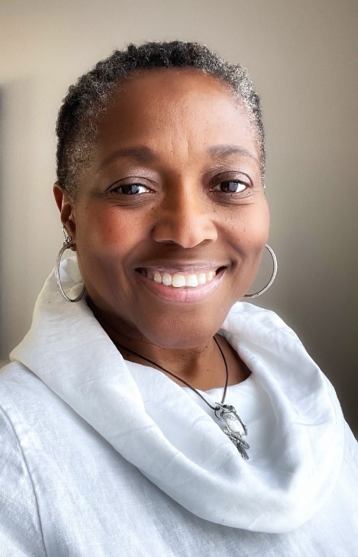
Rev. Dr. Karen Georgia Thompson
The United Church of Christ is poised to make a historic choice.
After a year-long process, the UCC Board voted March 4 to nominate Associate General Minister, the Rev. Karen Georgia Thompson, for General Minister and President.
If elected by the General Synod this summer, Thompson would be the first woman — and the first woman of African descent — to lead the denomination.
“We couldn’t have more faith in Rev. Dr. Karen Georgia Thompson,” said the Rev. Cameron Barr, UCC Board chair. “She has articulated our shared values on a global stage as Ecumenical Officer and Associate General Minister, and now, provided that she is elected by General Synod, she will be our spiritual leader.”
“We sought a leader who will champion the UCC’s mission and values both within the church and externally; embody an adaptive, resilient leader who can guide the UCC through rapidly changing times; and provide a foundation for the church’s future stability and growth,” said the Rev. Emma Brewer-Wallin, chair of the Search Committee that recommended Thompson. “And the Search Committee is clear that we have found such a leader in Rev. Thompson.”
Thompson’s vision for the future of the UCC embodies the values at the heart of her work: religious multiplicity and diversity, justice for marginalized communities world-wide and broader affirmation of spiritual practices beyond mainline Christianity.
“My hope is that we, the UCC, will begin to live more fully into what it means to be a church that proclaims to be God-centered and Spirit-filled,” Thompson said. “It’s not just about the head, but also about the heart. How do we become mission-minded? How do we show up? How do we be present for communities that are on the margins — not just here, but globally?”
Thompson would bring a global, interfaith perspective to the UCC’s highest office. In her current role, she leads Wider Church Ministries and serves as Co-Executive of Global Ministries. In September, Thompson was elected to the Executive Committee of the World Council of Churches.
This passion for international, interreligious collaboration and thirst for justice, especially for people of African descent, grew out of Thompson’s roots.
Born in Kingston, Jamaica, she immigrated to New York City as a teenager, eventually graduating from Brooklyn College. She later obtained a Master of Public Administration from North Carolina Central University and a Master of Divinity from Union Theological Seminary in New York.
She received her Doctorate in Ministry from Seattle University, publishing her dissertation on the multiple religious traditions practiced by African Caribbean people.
Her interlocking identities as a Black woman, an African descendant, a Jamaican immigrant, a poet and a public theologian all are central to Thompson’s life, work and ministry.
Thompson will become the first woman to lead the UCC if she is affirmed by at least 60 percent of the delegates at General Synod 34, to be held June 30-July 4.
She expressed a hope that the UCC would continue to be a “united and uniting” church as it moves through the 21st century and into the 22nd.
“The possibility of uniting is yet to be explored,” she said. “I would like to see the United Church of Christ continue to live into this ecumenical witness.”
# # #
The United Church of Christ, a mainline Protestant denomination, has more than 770,000 members and over 4,700 congregations nationwide. Headquartered in Cleveland, it is a church of many firsts: the first mainline denomination to ordain a woman, the first to ordain an openly gay man and the first predominantly white denomination to ordain an African American.

