7

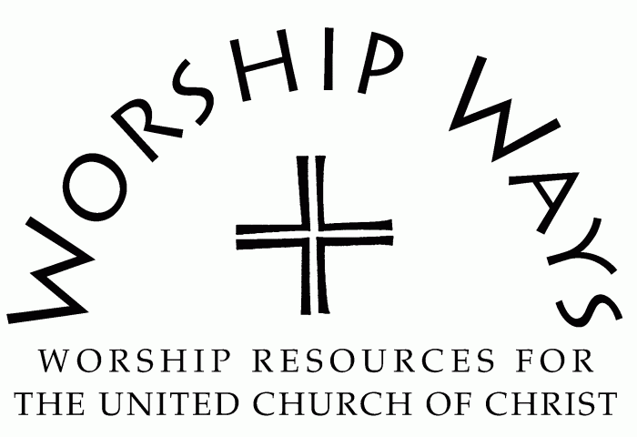

Sunday, September 15, 2024

Seventeenth Sunday after Pentecost

Mark 8:27-38 | *"Identity"*

**Call to Worship (Inspired by Psalm 116)**

One: Call upon the Holy One, who is gracious and merciful.

Many: We love the Holy One, who has heard our cry, responds to our prayers, and abides with us through our distress.

One: Call upon the Holy One, who is gracious and merciful.

Many: We praise the Righteous One, who protects, provides, and prepares their people.

One: Call upon the Holy One, who is gracious and merciful.

Many: We worship the Radiant One, who walks before us in the land of the living.

**Invocation**

Creator, we have come in response to your call to worship you. We have come to be in community with our neighbor. We have come onsite and online. We have come with quiet contemplation and boisterous joy. We have come in grief and with hope. We come to gather in your name, to honor your presence, and to give you praise. Amen.

**Prayer for Transformation and New Life**

Loving God, we confess that you are a God of transformation and a solid rock. We strive to be like trees planted by the water, steadfast and unmovable at the same time that we embrace your continuing creative acts in the world and in our lives. We struggle at times to know when to remain firm and when to progress forward. Infuse us with your wisdom and discernment along with courage and grace to be fully who you have created us to be.

**Words of Grace**

Beloved, God knows the journey that has shaped you, honors the efforts you have undertaken, and sustains you when you extend yourself forward. The Righteous One is merciful and grace-filled. Creator delights in you. Be bold and encouraged for the Sovereign One believes in you and goes with you.

**Invitation to Generosity**

The Holy One creates, sustains, and renews with abundant generosity. Let us demonstrate our participation in the kindom, our trust in God, and our stewardship of our resources through our giving to support our collective ministry.

**Prayer of Thanksgiving and Dedication**

Generous God, may these gifts honor your name and your generous Spirit alive within us. We thank you for the opportunity and privilege of contributing to your kindom and our world.

**Benediction**

May you reflect the goodness of God in the land of the living.

May you appreciate the beauty of God’s creation.

And may you know and be known in every encounter.

Rest in the identity of the Holy One as you go in the peace of your identity. Amen.

***Inclusion*: Service Prayers for the Seventeenth Sunday after Pentecost Year B** was written by the Rev. Dr. Cheryl A. Lindsay who serves as Minister for Worship and Theology for the United Church of Christ.